**Personalizati o tema, folosind pachete predefinite, precum DBMS_JOB, DBMS_DDL, DBMS_SQL**

Am creat mai intai o tabela pe care vom testa aceste pachete:  
  
CREATE TABLE example_table (

id NUMBER,

name VARCHAR2(100)

);

Am Programat un “Job” sa inseram date (**DBMS_JOB**) cu delay de un minut:

DECLARE

job_number NUMBER;

BEGIN

DBMS_JOB.submit(

job => job_number,

what => 'BEGIN

INSERT INTO example_table VALUES (1, ''John'');

INSERT INTO example_table VALUES (2, ''Jane'');

COMMIT;

END;',

next_date => SYSTIMESTAMP + INTERVAL '1' MINUTE

);

COMMIT;

DBMS_OUTPUT.PUT_LINE('Job Number: ' || job_number);

END;

/

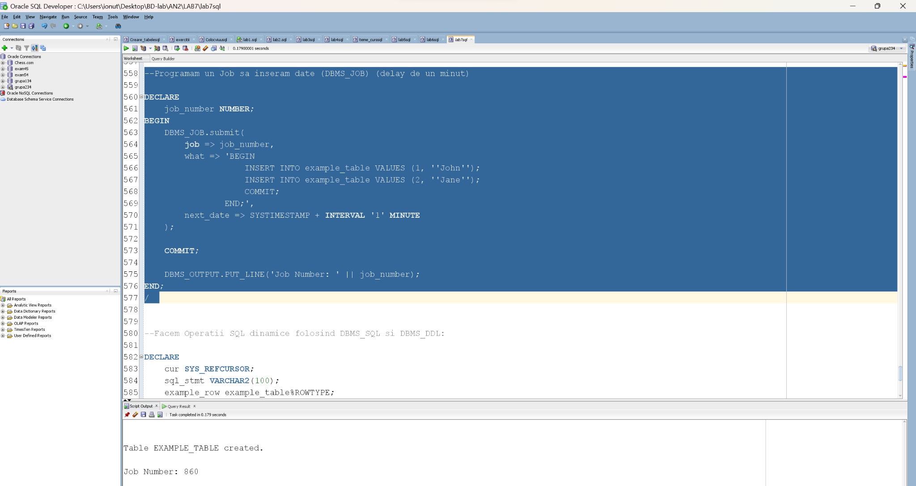

Dupa un minut:  
  
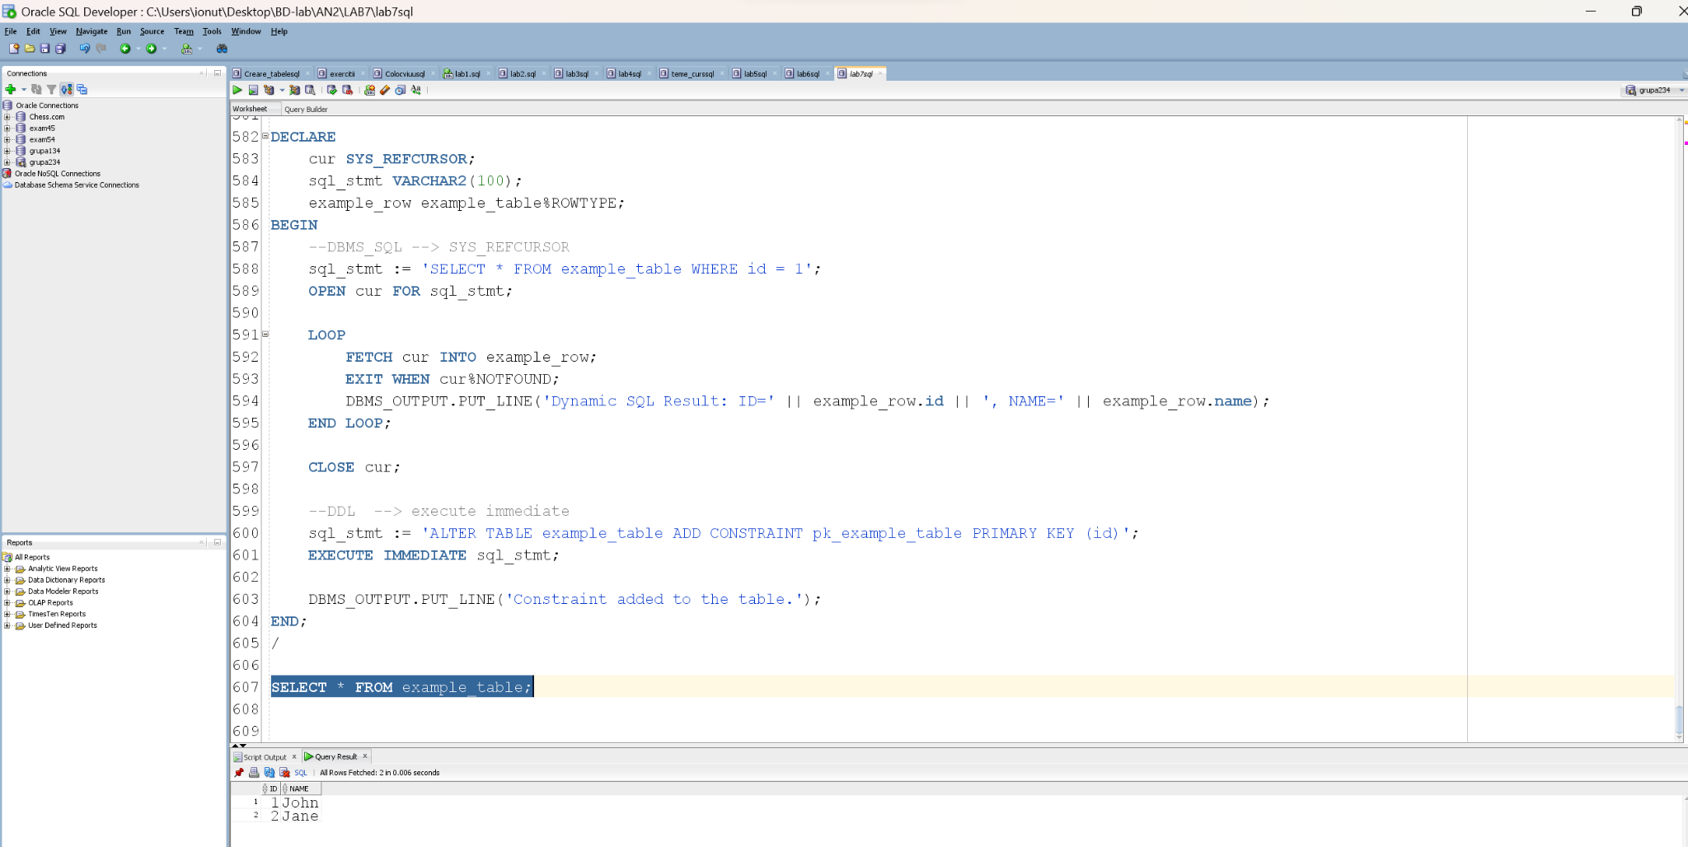

Facem Operatii SQL dinamice folosind **DBMS_SQL** si **DBMS_DDL**:

Folosim DBMS_SQL pentru a selecta date din tabela bazata pe o conditie. De asemenea, folosim DBMS_DDL pentru a adauga o cheie primara in mod dinamic tabelei.

DECLARE

cur SYS_REFCURSOR;

sql_stmt VARCHAR2(100);

example_row example_table%ROWTYPE;

BEGIN

--DBMS_SQL --> SYS_REFCURSOR

sql_stmt := 'SELECT * FROM example_table WHERE id = 1';

OPEN cur FOR sql_stmt;

LOOP

FETCH cur INTO example_row;

EXIT WHEN cur%NOTFOUND;

DBMS_OUTPUT.PUT_LINE('Dynamic SQL Result: ID=' || example_row.id || ', NAME=' || example_row.name);

END LOOP;

CLOSE cur;

--DDL --> execute immediate

sql_stmt := 'ALTER TABLE example_table ADD CONSTRAINT pk_example_table PRIMARY KEY (id)';

EXECUTE IMMEDIATE sql_stmt;

DBMS_OUTPUT.PUT_LINE('Constraint added to the table.');

END;

/

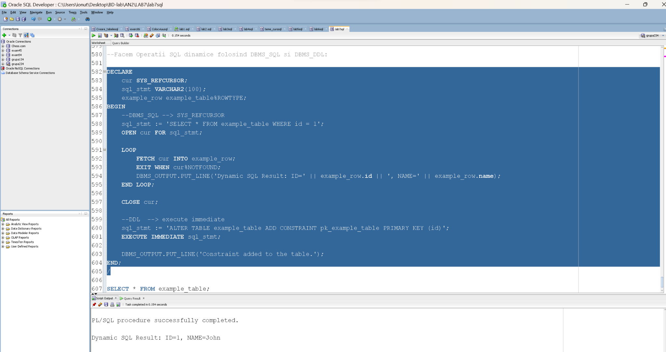

**Se poate defini o variabila globala a carei valoare sa poata fi citita sau modificata din sesiuni diferite?**

Raspunsul este ca da, se poate.

Intr-o sesiune cream urmatorul pachet, cu variabila my_variable globala:

CREATE OR REPLACE PACKAGE my_package AS

my_variable NUMBER;

END my_package;

CREATE OR REPLACE PACKAGE BODY my_package AS

BEGIN

my_variable := 42;

END my_package;

In cealalta sesiune afisam valoarea din pachet:  
  
SET SERVEROUTPUT ON;

DECLARE

v_value NUMBER;

BEGIN

v_value := my_package.my_variable;

DBMS_OUTPUT.PUT_LINE('Value: ' || v_value);

END;

